Creative Code tutorials

# TimeFrame

The project should not take more than two work weeks (excludes weekends) of production time, with deliverables expected in Mid November. This is based on the estimated budget of R10,000.

# Project Summaries

Currently the projects are too ambitious too meet the timeframe listed above and should therefore be reduced in scope to meet the proposed timeframes, or greater budget allocated or additional professional assistance leveraged.

1. The GitHub project archives the lessons conducted at iKhamva, and has two suggested methods for implementation of which one needs to be decided upon and discussed further.

-Estimated production timeframe 5 days

1. The Logo Designer Project is a simple shape drawing Mobile App that teaches learners about code through CSS and styling.

-Estimated production timeframe 8 days

1. The Animation App Project Export the Processing app as a JS app for implementation within a Hybrid Mobile App

-Estimated production timeframe 1 days

1. Resolving differences between Webkit and Gecko re. porting to Nokia Asha

-Estimated production timeframe 3 days

Total 17 Days @7 week days over.

# Proposed Revisions

1. GitHub Project has two possible scenarios for implementation.

**Scenario 1)** Interactive Lessons: The lessons are archived as an interactive, multi-lingual app that adopts a read, test, score approach (see below). The current budget will not allow for every lesson to be incorporated into the app. At the most 2 to 4 lessons could be considered for inclusion.

**Scenario 2)** Documentation-Based: The lessons are archived in conventional documented format, including lessons plans, illustrations and assignments. Most lessons can be included,

## What is code?

**Create your own pixel art**

**Create your own name tag**

**Understanding shapes and coordinates**

## Variables – custom-made Pacman

## If statement – Pacman

## Using a ‘for’ loop to create a pattern.

## Design your own pixel art characters for a Pacman mod.

## Design your own pixel art characters for a Mario mod.

# Github Project

**Scenario 1.**

Do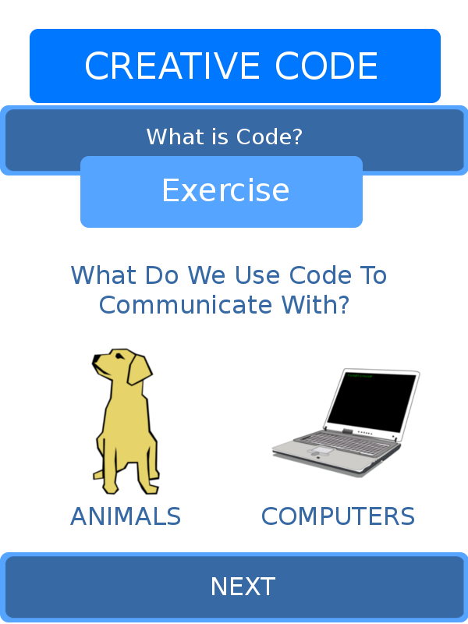es not represent final interface represents funct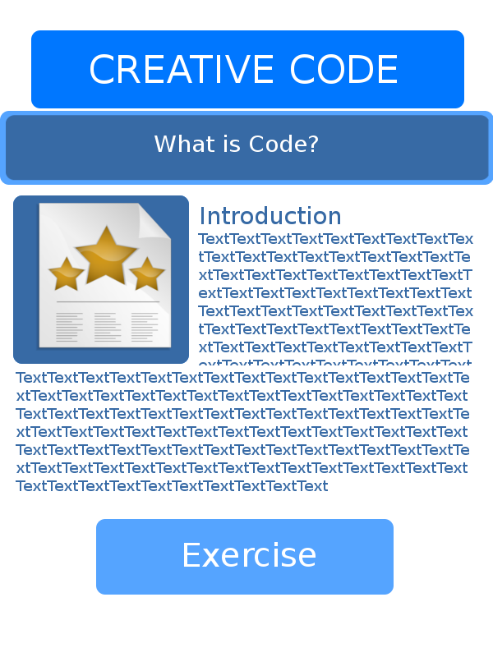io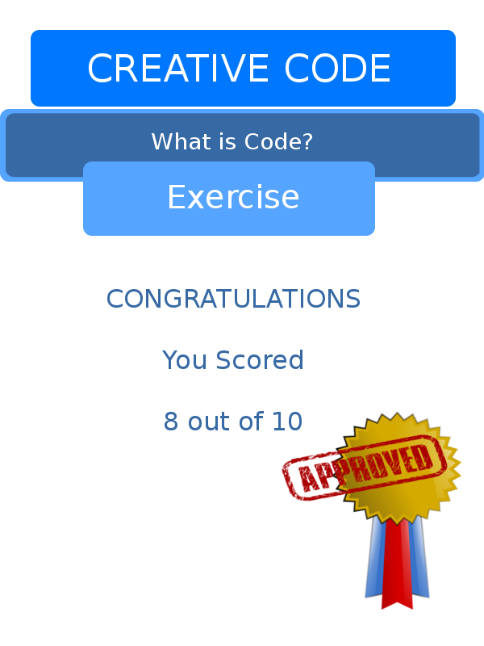nality.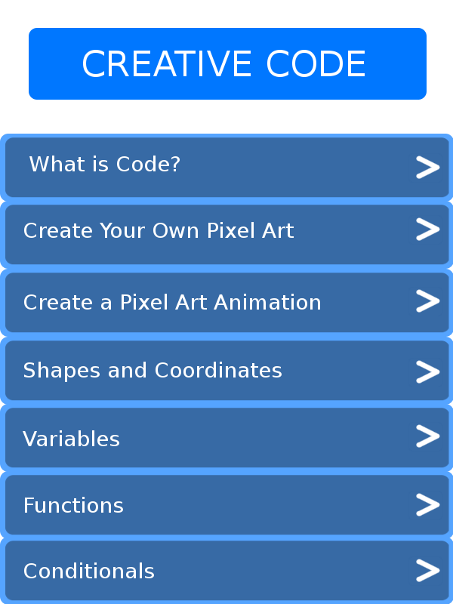

# Feature Phone Logo Designer

Goal is for User to learn about the effects of adjusting parameters in Code and relationship to changes on the display. Subsequently user will be able to add parameters, adjust colors, change positions related to shapes.

Shapes can be layered to form more complex shapes. Shadows can be added to shapes and text can be added.

When design is completed image is exported. Social Media Integration will not be included due to time limitations.

Illustration does not reflect finalized interface.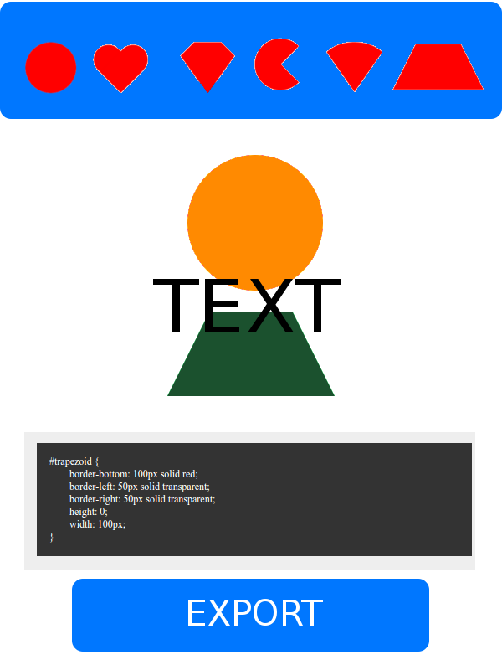

Select Shape.

Multiple Shapes can be

selected for the same

image

Canvas Area can only

Be edited

programmatically

Editing Area, Displays

Initial state of CSS and

Permits further textual

Input.

Export to Image for

Sharing manually

# Animator app

* No major adjustments to current codebase
* Export app as Processing.js
* Integrate into Gecko and Webkit Hybrid Apps